

VistA Blood Establishment Computer Software (VBECS) 2.0.0 SQL Server 2012

Installation Guide

November 2014

Department of Veterans Affairs
Product Development

This page intentionally left blank.

Revision History
Date | Revision | Description | Author
04-05-13 | 1.0 | Initial Version | BBM Team
05-14-13 | 2.0 | Addressed DR 4610: Initial Configuration: added 2 new sections to account for Active Directory verification (Verify the Cluster Account and Verify the Virtual Network Name (VNN) Account. | BBM Team
12-05-13 | 3.0 | Updated the footer: Changed “May” to “December” and “Version 2.0” to “Version 3.0”.  Changed “May” to “December” on title page.  Introduction section: Added Post-Installation Checklist  Global:  - Worksheet (14, Value) to Worksheet (C8, Value)  - Worksheet (12, Name) to Worksheet (C7, Value)  - Worksheet (11, Value) to Worksheet (C5, Value)  - Worksheet (13, Value) to Worksheet (C7, Value)  - Worksheet (12, Value) to Worksheet (C6, Value)  - Worksheet (12, Value) to Worksheet (C6, Password)  Initialized the New Disks section: Revised Step 6.  Post Installation Tasks section: Added Step 3. | BBM Team
12-12-13 (continued on next page)  12-12-13 (continued from previous page) | 4.0  4.0 | Updated the footer: Changed “Version 3.0” to “Version 4.0”.  Global: Revised Worksheet notations.  Global: Resized some screen shots.  Global: Changed “capture the screen” to “capture a screen shot”.  Screen Captures section: Elaborated on screen capture descriptions.  Page 12: Updated Figure 9.  Page 13, Step 7: Removed “the” after “Canonical name”.  Page 15, Step 2: Added “Select the Security tab”.  Page 16, Step 1: Added to run oobe command if needed.  Page 17, Step 2: Added “Select the Performance tab”.  Page 18: Modified Firewall step.  Page 22, Step1: Added Login after reboot and updated Figure 29.  Page 23: Removed Step 4c and updated Figure 30.  Page 25: Added a note to Step 5.  Page 26: Reworded Steps 6 and 7. Updated Figures 35 and 36.  Page 27: Reworded Step 9 to match new Steps 6 and 7.  Page 30: Clarified Step 9 and added “Example of” to Figure 42.  Page 30: Removed Step 1 under Create the Cluster section.  Page 35, Step 11: Clarified warnings check.  Page 36, Step 15: Removed credentials prompt.  Page 37, Step 17: Removed error sentence.  Page 39, Step 24: Added wait (network latency).  Page 42, Step 34: Clarified Step 34.  Page 44: Added “press any key” to Step 6 and updated Figures 65 and 66.  Page 48, Step 7: Added “if not checked”.  Page 48, Step 11: Revised for clarification.  Page 56, Step 37: Revised for clarification.  Page 57, step 37: added DR subnet mask  Page 57, Step 39: Revised for clarification.  Page 60: Removed vSphere step and changed “server” to “cluster”. | BBM Team  BBM Team
05-23-14 | 5.0 | Global: Replaced Server 1 with Server A, Server 2 with Server B and Server 3 with Server C.  Global: Replaced “HinesVbecsNMEAAccounts” with “HinesVbecsProdSQLSupport”.  Global: Replaced all screen captures.  Global: Changed the following:  - [Worksheet: C6, Value)] to [Worksheet: 7, Name)]  - [Worksheet: C7, Value)] to [Worksheet: C6, Value)]  - [Worksheet: C8, Value)] to [Worksheet: C7, Value)]  - [Worksheet: C10, Value)] to [Worksheet: C9, Value)]  - [Worksheet: C11, Value)] to [Worksheet: C10, Value)]  Prerequisites section: Added new second bullet about AITC creating the SQL Server service accounts in Active Directory. Added new fourth bullet to verify that ports are unblocked on the Firewall of the Disaster Recovery site.  Prerequisites section: Add bullet to ensure an EO AD System Administrator created the Cluster and VNN objects.  Changed “Configuration Worksheets” section title to “Data Center Worksheets” and revised.  Server Configuration:  Initial Configuration Tasks section: Revised lead-in sentence. Revised all steps.  Verify the Virtual Network Name (VNN) Account section: Removed lead-in sentence and revised Steps 1 and 2.  Verify the Server section: Revised section.  Configure Operating System (OS) to Recognize New Disks section: Revised section.  Initialize the New Disks: Revised section.  Cluster Installation:  Pre-Installation Connectivity Checks section: Revised Steps 1 and 2.  Install Clustering section: Revised.  Create the Cluster section: Revised.  Create the Cluster section, Step 29: Revised step to get the File Share server information for the Data Center worksheets.  Create the Cluster section, Step 34: Revised.  SQL Server 2012 Configuration:  SQL Server 2012 Installation section: Revised.  SQL AlwaysOn Server Configuration section: Revised Steps 1, 4, 7 and 8.  Configure the Availability Group (AG): Revised.  SQL Server 2012 Configuration: Added Resolving Database Vulnerability Scan Issues section for the Database Vulnerability Scan resolution for the SQL Servers.  Post-Installation Tasks: Revised. | BBM Team
07-09-14  (continued on next page)  07-09-14  (continued from previous page) | 6.0  6.0 | Updated the footer: Changed “May” to “July” and “Version 5.0” to “Version 6.0”.  Changed “May” to “July” on title page.  Cluster Installation, Create the Cluster section: Added Step 14 and Figure 46.  SQL Server 2012 Configuration, SQL Server 2012 Installation section: Revised Step 10.  Post-Installation Tasks section: Added Step 1, Print and fill-out the Date Completed and Installer Name fields on the validation form for each server. | BBM Team  BBM Team
08-08-14 | 7.0 | Updated the footer: Changed “July” to “August” and “Version 6.0” to “Version 7.0”.  Changed “July” to “August” on title page.  Cluster Installation, Pre-Installation Connectivity Checks: Added Step 3 to disable the Backup network adapter on all 3 server nodes.  Post-Installation Tasks: Added a new Step 1 to enable the Backup network adapter on all 3 server nodes. | BBM Team
08-19-14 | 8.0 | Updated the footer: Changed “Version 7.0” to “Version 8.0”  Global- Changed “local installer account” to “local administrator account”. (DR 5071) | BBM Team
09-16-14 | 9.0 | Updated the footer: Changed “August” to “September” and “Version 8.0” to “Version 9.0”.  Changed “August” to “September” on title page.  Global: Changed “local administrator account” to “domain administrator account”.  Global: Added statements indicating who runs a particular section of the guide.  Global: Added a box around all steps that require a screen capture.  Global: Changed “validation form” to “validation.rtf document”.  Server Configuration:  - Warning box: Revised.  - Removed sections: Configure Operating System (OS) to Recognize New Disks and Initialize the New Disks. These sections will be added to the VBECS 2.0.0 Data Center Installation Guide document.  - Added Verify the New Disks section.  Create the Cluster:  Added a step to check the box on the Installation checklist for setting the DR nodeweight to 0.  - Added a step to check the box on the Installation checklist after configuring the Quorum share folder.  - Added a step to check the box on the Installation checklist after copying the Cluster installation logs to the validation folder.  SQL Server 2012 Installation:  - Added a step to check the box on the Installation checklist after copying the SQL Server setup logs to the validation folder.  Configure Availability Group (AG):  - Added a step to check the box on the Installation checklist after configuring the AG folder.  Post-Installation Task:  - Added Steps 1 and 2. (DR 5075) | BBM Team
10-06-14 | 10.0 | Updated the footer: Changed “September” to “October” and “Version 9.0” to “Version 10.0”.  Changed “September” to “November” on title page.  Initial Configuration Task section:  Verify the Cluster Account, Step 6: Changed “HinesVbecsProdSQLSupport” to “HinesVbecsNMEAAccounts”.  Replaced Figure 4. (DR 5089) | BBM Team
11-03-14  11-03-14  (continued from previous page) | 11.0  11.0 | Updated the footer: Changed “October” to “November” and “Version 10.0” to “Version 11.0”.  Changed “October” to “November” on title page.  Globally changed “EO System Administrator” to “EO VBE Windows System Administrator”.  Verify the New Disks section:  - Removed steps for disabling the network adapter.  - Step 6: Changed “EO vSphere System Administrator” to “EO VBE Windows System Administrator”.  Pre-Installation Connectivity Checks section:  - Added steps for disabling the network adapter.  SQL Server AlwaysOn Configuration section:  - Revised Step 6 and added new Step 7.  Post-Installation Tasks section:  - Remove the step for the EO VBE Windows System Administrator to enable the network adapters for the servers.  - Added step to install Microsoft Visual Studio Service Pack 1 on Servers A, B and C using Windows Update.  - Revised Step 9. (DR 5101) | BBM Team  BBM Team

Table of Contents

Revision History 3
Introduction 9
Prerequisites 10
Data Center Worksheets 10
Installation Checklist 10
Post-Installation Checklist 10
Screen Captures 10
Server Configuration 13
1 Initial Configuration Tasks 13
2 Verify the Server 19
3 Verify the New Disks 22
Cluster Installation 23
1 Install Clustering 23
2 Create the Cluster 26
SQL Server 2012 Configuration 39
1 SQL Server 2012 Installation 39
2 SQL AlwaysOn Server Configuration 43
3 Configure the Availability Group (AG) 44
Post-Installation Tasks 57
Index 59

This page intentionally left blank.

Introduction
This guide details the installation and configuration of a SQL Server system to support VBECS 2.0.0. Each SQL system will be composed of 3 servers in a SQL Server 2012 AlwaysOn cluster. The first server will have the role of primary and will field all database requests. The second server will have the role of High Availability (HA) replica. If the primary server should fail, the HA server will automatically assume the role of the primary. The third server will have the role of Disaster Recovery (DR) replica and will reside in a different physical location. If the primary and HA server were both unreachable, the DR server can be manually failed over to assume the role of the primary.
Regions 1, 2 and 4 will have two production SQL systems for a total of 6 servers. Region 3 will have 3 production SQL systems for a total of 9 servers. Additionally, each region will have one test system that is a scaled down version of the production system.
This guide details the installation of one system. This guide will have to be executed in its entirety for each production and test system being configured (e.g., Region 3 will need to execute this guide 4 times: 3 times for the production systems, plus 1 time for the test system). See Table 1 for a breakdown of the number of systems and servers by region.
Table 1: System and Server Counts
Region | Production SQL Systems | Production Servers | Test SQL Systems | Test Servers | Total Servers
1 | 2 | 6 | 1 | 3 | 9
2 | 2 | 6 | 1 | 3 | 9
3 | 3 | 9 | 1 | 3 | 12
4 | 2 | 6 | 1 | 3 | 9

Unauthorized access or misuse of this system and/or its data is a federal crime. Use of all data must be in accordance with VA security and privacy policies.
If any problems or questions arise in the course of the installation, file a ticket in Remedy for assistance.

Prerequisites
The following tasks must be completed before beginning this installation:
- The SQL Servers must be created in the vSphere environment.
- AITC creates the SQL Server service accounts in Active Directory and shares the account information with the VBECS Team.
- The cluster and virtual network name account must be configured in Active Directory.
- The EO VBE Windows System Administrator must verify that their non-eMail enabled account (NMEA) administrator account can log into all 3 SQL Server systems.
- The EO VBE Windows System Administrator must verify that the domain administrator account [Worksheet: C6] can log into all 3 SQL Server systems.
- The EO Database Administrator must verify that their NMEA administrator account can log into all 3 SQL Server systems.
- The EO Database Administrator must verify that the domain administrator account [Worksheet: C6] can log into all 3 SQL Server systems.
- EO Active Directory (AD) System Administrator must create Cluster and VNN objects.
- Verify with AITC that the following Firewall ports have been unblocked at the Disaster Recovery site:
  - TCP/135, UDP/137, TCP/1433, TCP/1434, TCP/3343, UDP/3343, TCP/5022 and TCP/49152-65535
  - ICMP
For instructions on completing these tasks, see the VBECS 2.0.0 Data Center Installation Guide.

Data Center Worksheets
In the VBECS 2.0.0 Data Center Worksheets document, each region has a worksheet that needs to be filled out prior to beginning the installation. Print a copy of this completed worksheet; its contents are referenced throughout this document using the following format: [Worksheet: (row, column]). For example, the following notation [5a, Public IP] is requesting the value from the Public IP column of the Data Center Worksheet for Item 5a.

Installation Checklist
A checklist (see the VBECS 2.0.0 SQL Server 2012 Installation Checklist document) has been provided to ensure that each section of this guide is completed for the required servers. Print a copy of the checklist for each SQL Server System being configured and mark it only when instructed. Save a copy of the checklist as a record of work done. Upon completion, the checklist will be signed and dated and a scanned copy will be stored on the server for validation records.

Post-Installation Checklist
A checklist (see the VBECS 2.0.0 SQL Server 2012 Post-Installation Checklist document) has been provided to validate the VBECS 2.0.0 SQL Server Installation Guide process. This checklist must be executed by someone other than the person who installed SQL Server 2012 using the VBECS 2.0.0 SQL Server 2012 Installation Guide.

Screen Captures
Because VBECS is a medical device, screen captures must be captured and logs printed at various points throughout the installation to meet FDA requirements for objective evidence and documentation. A (Camera) at the beginning of each step that requires a screen capture will identify these points. Record all screen captures in the validation.rtf document located on each server at C:\validation. Above each screen capture, type the document name, page and step number.
This page intentionally left blank.

Server Configuration
Sections 1 through 3 must be executed by an EO VBE Windows System Administrator other than the one who deployed the servers from the VBECS template to verify the install.

Initial Configuration Tasks

Verify the Cluster Account
These steps require Active Directory permissions.
- Launch the Active Directory Users and Computers tool.
- If the tool does not open to the domain listed in [Worksheet: C7, Value], right-click the domain and select Change Domain; specify the correct domain and click OK (Figure 1).
Figure 1: Example of Active Directory Users and Computers
Image redacted
- Right-click the domain and select Find (Figure 2).
- Select Computers and enter the cluster account of the current SQL Server system [Worksheet: 4, Name)] in the Computer name field. Click Find Now (Figure 2).
Figure 2: Example of Find Computers
Image Redacted
- The cluster account must be disabled in order for the installation to succeed. Right-click on the search results to display the pop-up menu. If there is a menu option named Enable Account, the account is already disabled. If the menu option Disable Account is visible, select to disable the server account. Select Properties from the pop-up menu to continue (Figure 3).
Figure 3: Example of Active Directory Users and Computers
Image Redacted
- Click on the Security tab and select the HinesVbecsNMEAAccounts account in the top pane. Uncheck the boxes as needed to match the permissions in Figure 4, Figure 5 and Figure 6; then click Apply.
Figure 4: Example of Cluster Properties
Image Redacted
Figure 5: Permissions
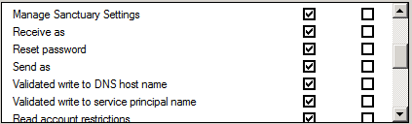
Figure 6: Permissions
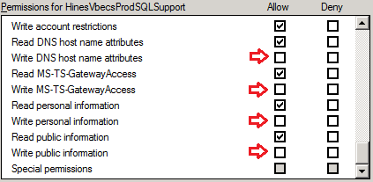
- Select the Object tab (Figure 7). The Canonical name of object field denotes the full path to the cluster object in Active Directory. Navigate to this directory in the main Active Directory Users and Computers window. Once there, click OK to close the cluster account Properties window.
Figure 7: Example of Cluster Properties
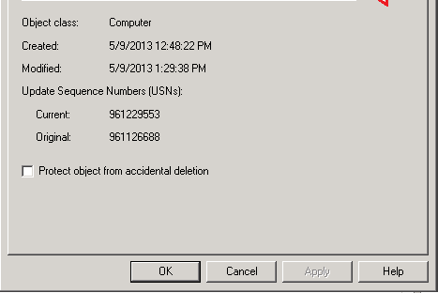
- Right-click on the folder that contains the cluster account and select Properties (Figure 8).
Figure 8: Example of Active Directory Users and Computers
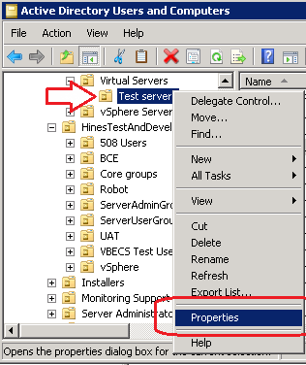
- Click the Security tab (Figure 9). Locate and select the cluster account of the current SQL Server system [Worksheet: 4, Name] in the top pane (the account name will end with a $). Scroll through the permissions in the bottom pane and make sure the following two permissions are allowed before clicking OK to continue:
- Read RTCUserProvisioningPropertySet
- Read RTCUserSearchPropertySet
Figure 9: Example of Folder Properties
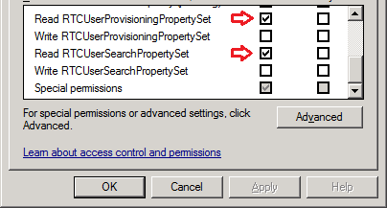

Verify the Virtual Network Name (VNN) Account
- In the Active Directory Users and Computers window, right-click on the domain and select Find. Select Computers in the Find option. Enter the VNN account of the current SQL Server system [Worksheet: 5n, Name] in the Computer name field and click Find Now (Figure 10).
Figure 10: Example of Find Computers
Image Redacted
- Right-click on the VNN account in the search results and select Properties. Select the Security tab and then select the cluster of the current SQL Server system [Worksheet: 4, Name] (the account name will end with a $). In the Permissions pane, if unchecked, check the Allow box for Full control. Repeat Steps 1 and 2 for all VNNs.
Figure 11: Properties
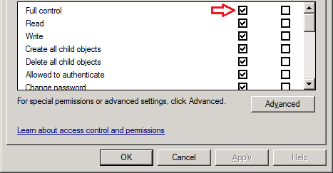

Verify the Server
- Login to Server A of the current SQL Server system [Worksheet: 1, Name] with the domain administrator account [Worksheet: C6]. If the Initial Configuration Tasks window (Figure 12) does not automatically appear, open it by clicking Start, Run, type oobe and click OK.
Figure 12: Example of Initial Configuration Tasks
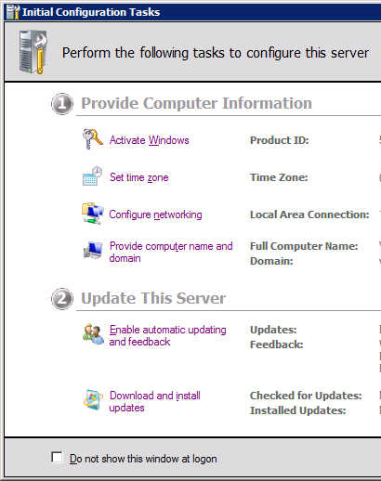
- Click on Activate Windows (Figure 13) and enter a valid product key (contact the EO VBE Windows System Administrator).
Figure 13: Example of Windows Activation
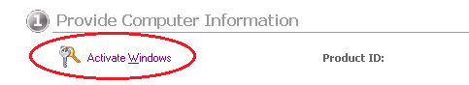
- Click Provide computer name and domain (Figure 14) and set the server and join the domain, using the values from [Worksheet: (1, 2 or 3, Name)] and [Worksheet: [C7, Value)] respectively. When joining the domain, you may get the error shown in Figure 15 which can be ignored; click OK to dismiss it.
Figure 14: Example of Computer Name and Domain Configuration
Figure 15: Example of the Ignorable Microsoft Message
Image Redacted
- If any firewall settings are On, firewalls must be turned off (Figure 16):
  - Click Configure Windows Firewall
  - Select Turn Windows Firewall on or off
  - Set all options to Turn off Windows Firewall as depicted and click OK
Figure 16: Turn off all Firewalls
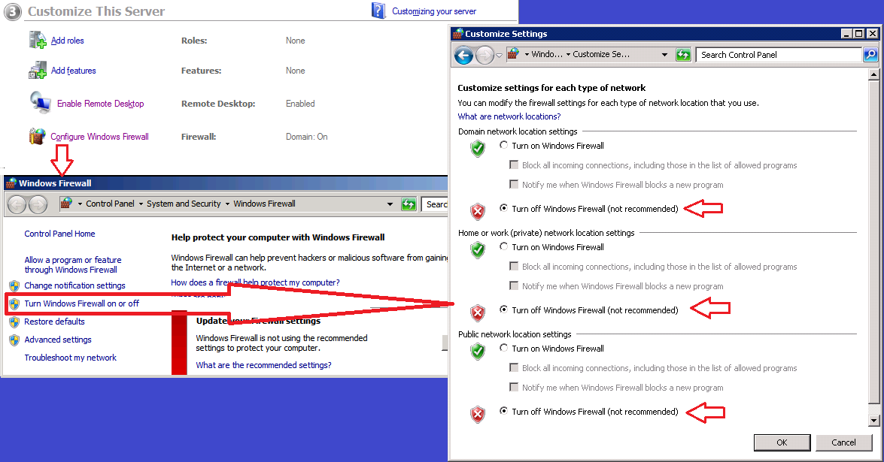
-  Place a screen capture of the full Initial Configuration Tasks window (Figure 12) in the validation.rtf document. **Maximize the window, if needed, to ensure all tasks are captured.
- Open Task Manager and select the Performance tab. Verify the server has four processors and 32GB of memory (Figure 17). Place a screen capture of Task Manager in the validation.rtf document.
Figure 17: Windows Task Manager
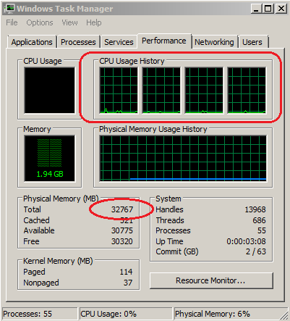

- Grant server privileges using the local Administrators group; click the Server Manager icon on the taskbar and expand the Configuration, Local Users and Groups option.
- Select the Groups folder and double-click Administrators group.
- Click Add (Figure 18).
Figure 18: Example of Administrator Properties
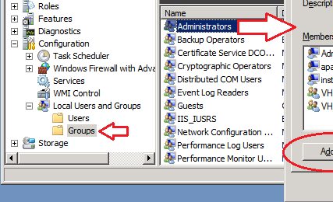
- You will be prompted to authenticate with a domain level account that has Active Directory permissions. Enter this user information and click OK (Figure 19).
Figure 19: Domain Authentication
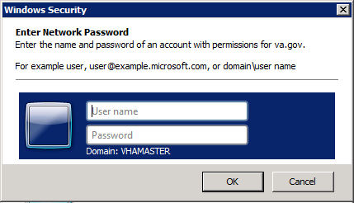
- Enter the group name(s) [Worksheet: C5, Value]. When finished, click OK (Figure 20).
Figure 20: Example of Select Users, Computers, Service Accounts or Groups
Image Redacted
- Click Apply on the Administrator Properties window and reboot the server.
- Check the Verify the Server box on the Installation Checklist for this server and repeat this section for each remaining server in the current SQL Server system.

Verify the New Disks
- Login to Server A of the current SQL Server system [Worksheet: 1, Name] with the domain administrator account [Worksheet: C6] and click the Server Manager icon on the taskbar.
- Select Storage, Disk Management.
- Verify that the disks are configured as required.
-  Place a screen capture of the Disk Management window showing the disks configured in the validation.rtf document (Figure 21).
Figure 21: Example of Configured and Initialized Disks
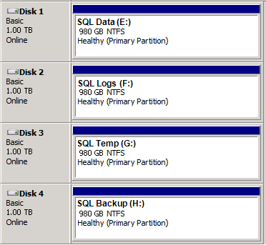
- Check the Verify the New Disks box on the Installation Checklist for this server.
- Complete the EO VBE Windows System Administrator Name field and Date Completed on the checklist form.
- Send the completed Installation Checklist to the EO Database Administrator to continue with the Cluster installation.

Cluster Installation

Sections 1 and 2 must be executed by an EO Database Administrator using the domain administrator account [Worksheet: C6].

Pre-Installation Connectivity Checks
- Consult with the EO VBE Windows System Administrator to ensure that Sections 1 through 3 under Server Configurations has been performed and the checklist completed.
- On Server A, open a command prompt and ping Server B’s public IP [Worksheet: 2, Public IP]. Ping Server C’s public IP [Worksheet: 3, Public IP].
- On Server B, open up a command prompt and ping Server C’s public IP [Worksheet: 3, Public IP].
- Disable the Network Adapters configured for Backups.
- Check the Disable Network Adapters for Backups box on the Installation Checklist and repeat this section for each remaining server in the current SQL Server system.
If any of the ping tests fail, do not proceed. Verify that adapter settings are correct and check with data center technicians to verify server configuration. All ping tests must pass before proceeding.

Install Clustering
- On Server A, return to Server Manager.
- Select Features and click Add Features (Figure 22).
Figure 22: Example of Adding Features with Server Manager
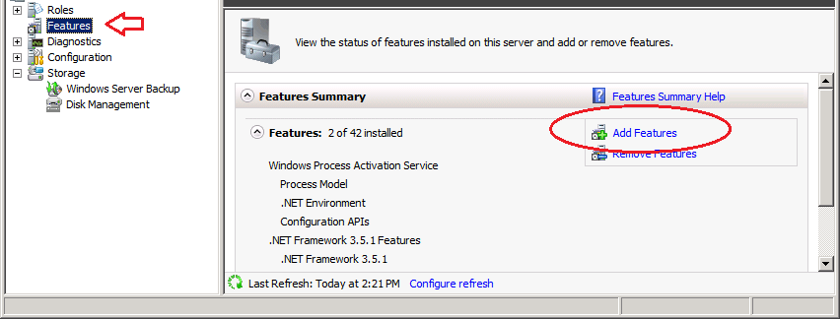
- Check Failover Clustering and click Next (Figure 23).
Figure 23: Add Features Wizard
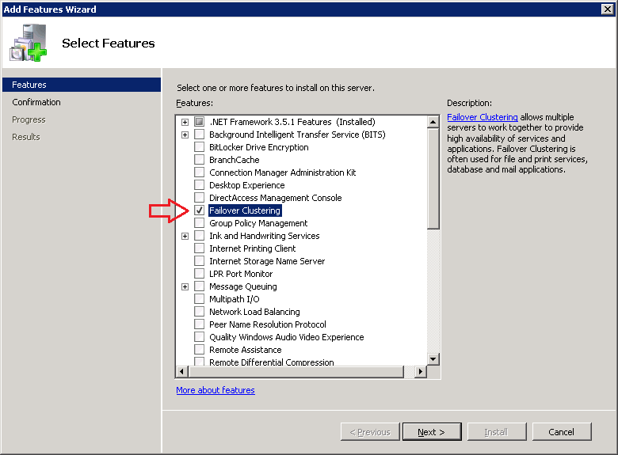
- Click Install (Figure 24).
Figure 24: Add Features Wizard Confirmation
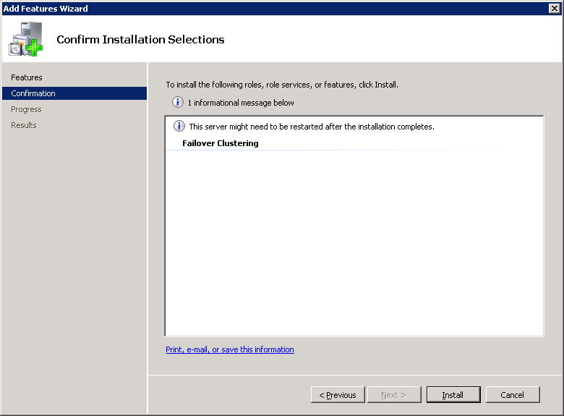
- Any warning messages can be ignored. Click Close (Figure 25).
Figure 25: Example of Add Features Wizard Completion
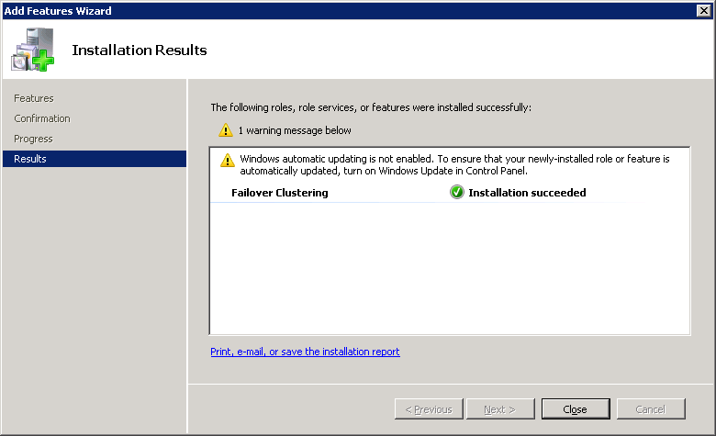
- Log off the server.
- Check the Install Clustering box on the Installation Checklist for this server, and repeat this section for each remaining server in the current SQL Server system.

Create the Cluster
- Login to Server A of the current SQL Server system [Worksheet: 1, Name] with a domain administrator account [Worksheet: C6].
- Click the Server Manager icon on the taskbar.
- Expand the Features group. Right-click on Failover Cluster Manager and select Create a Cluster… (Figure 26).
Figure 26: Example of Server Manager
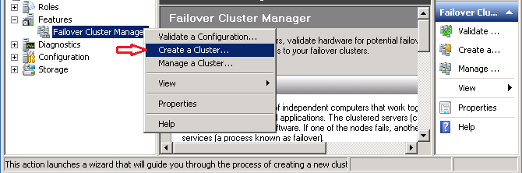
- Click Next (Figure 27).
Figure 27: Create Cluster Wizard
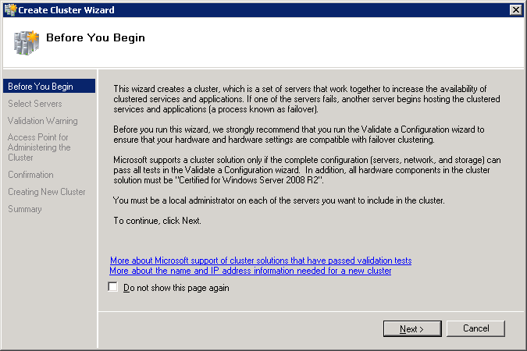
- Enter [Worksheet: 1, Name] in the Enter server name field and click Add.
- Repeat, adding [Worksheet: 2, Name] and [Worksheet: 3, Name]. Click Next (Figure 28).
Figure 28: Example of Adding Cluster Servers
Image Redacted
- Click Next (Figure 29).
Figure 29: Create Cluster Wizard – Validation Warning
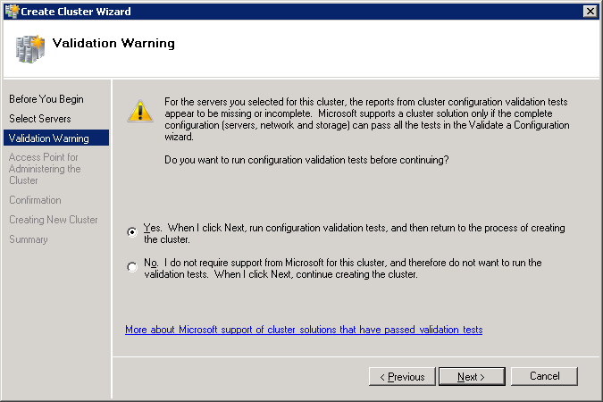
- Click Next (Figure 30).
Figure 30: Validate a Configuration Wizard
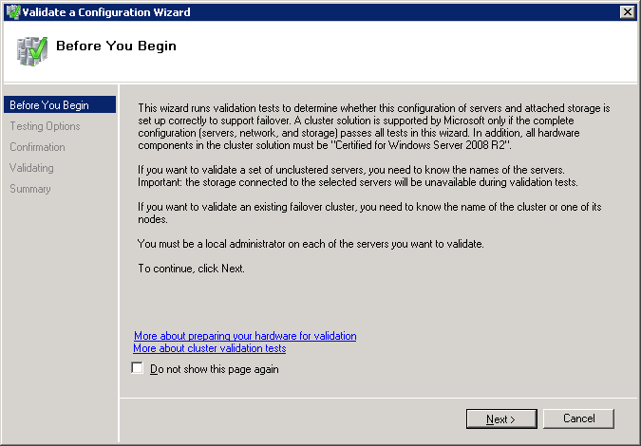
- Click Next (Figure 31).
Figure 31: Testing Options
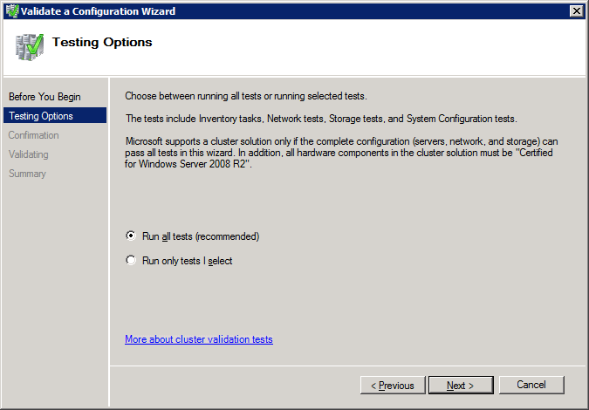
- Click Next (Figure 32).
Figure 32: Example of Validate a Configuration Wizard - Confirmation
Image Redacted
- After 5 to 10 minutes, the Failover Cluster Validation Report will display. Scroll through the entire report and verify that the Description column is “Success” for the Inventory and System Configuration sections. **The other sections are expected to contain warnings. Click Finish to continue (Figure 33).
Figure 33: Example of Failover Cluster Validation Report
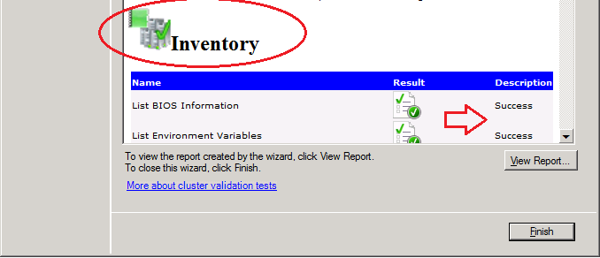
- Configure the cluster (Figure 34):
- In the Cluster Name field, enter [Worksheet: 4, Name]
- Click inside an Address cell to enable input and enter [Worksheet: 4, Public IP] and [Worksheet: 4, DR IP]. **Make sure the IPs entered belong to their corresponding networks. If you enter the wrong one, the SQ n t llation will fail.
- Click Next.
Figure 34: Example of Setting Cluster Access Point
Image Redacted
- Click Next (Figure 35).
Figure 35: Example of Cluster Creation Confirmation
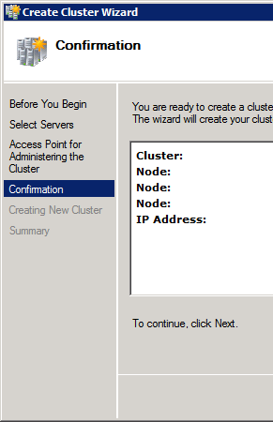
- Click Finish (Figure 36).
Figure 36: Example of Cluster Wizard Summary
Image Redacted
- If you notice an error message in the Cluster Events reading "Cluster resource ‘Cluster IP Address xx.xxx.xx.xx’ in clustered service or application ‘Group failed’", this can be ignored. This error message is expected since the IP address on the disaster recovery node is only active in the event of a failover (Figure 37).
Figure 37: Example of Server Manager
Image Redacted
- Open a command prompt window and type:
cluster node <Server C> /prop nodeweight=0
replacing <Server C> with [Worksheet: 3, Name] and press Enter (Figure 38).
Figure 38: Example of Setting the Cluster NodeWeight Parameter
Image Redacted
- Close the command prompt window.
- Check the Set the NODEWEIGHT of Server C box on the Installation Checklist for this server.

Configure the Quorum File Share
- Using the domain administrator account [Worksheet: C6], log on to the Quorum file share server using the IP:
- [Worksheet: C10, Value] for Production SQL System installations
- [Worksheet: C11, Value] for Test SQL System installations
- Open Windows Explorer and navigate to D:\Quorum shared folder.
- Right-click on the Quorum folder and select Properties.
- In the Quorum Properties window, select the Security tab and click Edit (Figure 39).
Figure 39: Example of Quorum Folder Properties
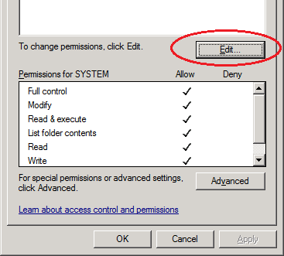
- Click Add. On the Select Users window, click Object Types. Check Computers and click OK (Figure 40).
Figure 40: Example of Adding Users
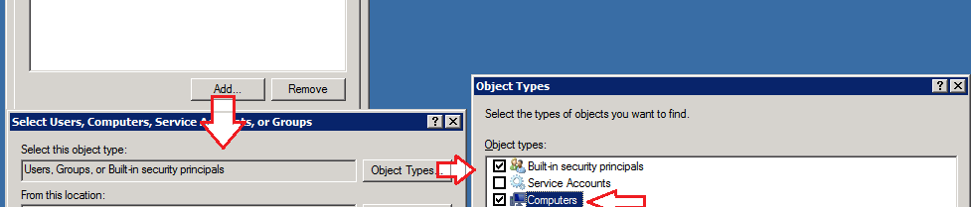
- Enter the cluster name [Worksheet: 4, Name] and click OK. If alerted that the object is disabled, wait 5 minutes and click OK again. With the cluster name selected in the Group list, check the Full Control box under the Allow Column and click OK (Figure 41).
Figure 41: Example of Adding the Cluster to the Quorum Share
Image Redacted
- Click OK to close the Quorum Properties window and logoff the Quorum server.
- Return to your connection on Server A. In the Server Manager window, expand the Failover Cluster Manager group, right-click the cluster and select More Actions, Configure Cluster Quorum Settings (Figure 42).
Figure 42: Example of Configuring Cluster Quorum Settings
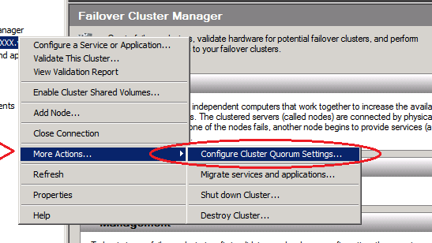
- Click Next (Figure 43).
Figure 43: Configure Cluster Quorum Wizard
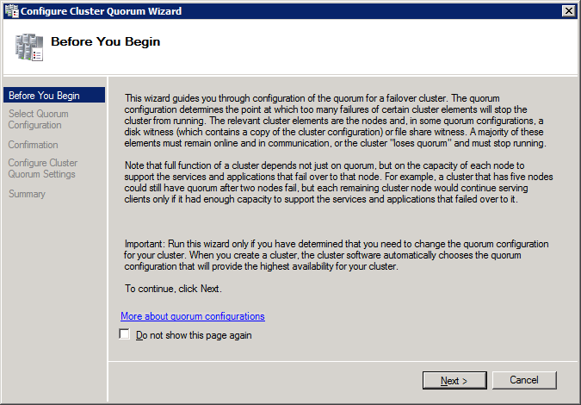
- Select Node and File Share Majority and click Next (Figure 44).
Figure 44: Configure Cluster Quorum Wizard –Select Quorum Configuration
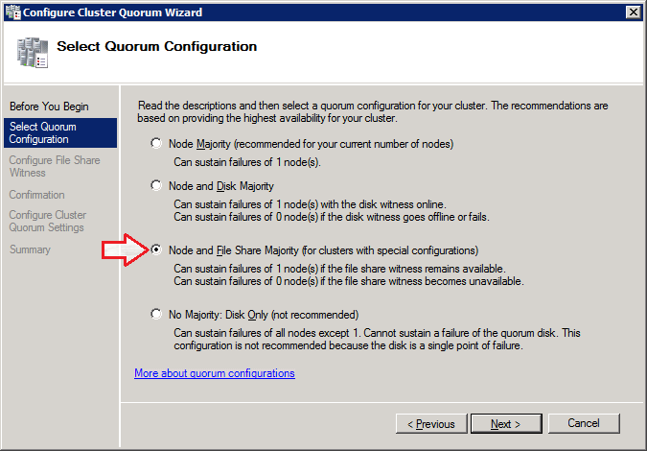
- In the Shared Folder Path field, enter the Quorum file share (e.g., \\IPREDACTED\Quorum) using the appropriate IP address and then click Next (Figure 45):
- [Worksheet: C10, Value] for Production SQL System installations
- [Worksheet: C11, Value] for Test SQL System installations
Figure 45: Example Configure Cluster Quorum Wizard – Configure File Share Witness
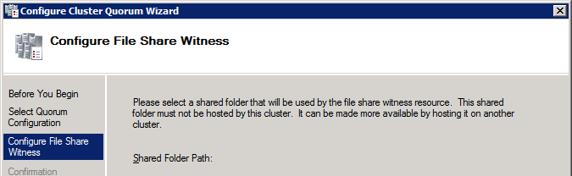
- Click Next (Figure 46).
Figure 46: Example of Configure Cluster Quorum Wizard – Confirmation
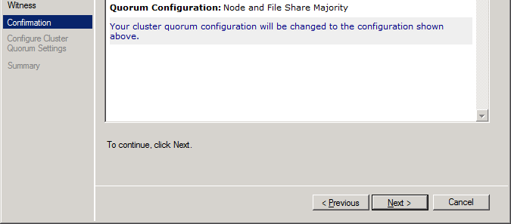
- Click Finish (Figure 47).
Figure 47: Example of Configure Cluster Quorum Wizard – Summary
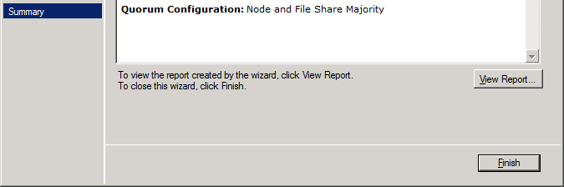
- Check the Configure the Quorum File Share box on the Installation Checklist for this server.
- Using Windows Explorer, copy the C:\Windows\Cluster\Reports folder to C:\validation\cluster.
Figure 48: Example of Saving the Cluster Reports Folder
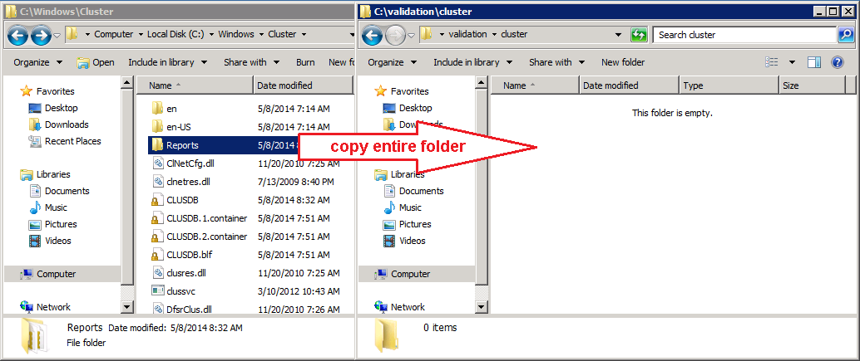
- Check the Copy the Cluster Reports folder box on the Installation Checklist for this server.
- Close any open applications and windows.
- Check the Create the Cluster box on the Installation Checklist.

SQL Server 2012 Configuration

Sections 1, 2 and 3 must be executed by an EO Database Administrator using their NMEA administrator account.

SQL Server 2012 Installation
- If needed, login to Server A [Worksheet: 1, Name] with a domain level account that has administrator permissions to the SQL Servers.
- Using Windows Explorer, navigate to C:\temp\SQL 2012. Double-click on the InstallSQL2012 Windows batch file.
Each Regional SQL Server System installation will have 2 SQL Server Service accounts (1 Pre-Production and 1 Production). Verify these service accounts are active before installing SQL Server.
- A command window opens prompting for a SQL Service account. Enter the domain and value from [Worksheet: 7, Name] and press Enter.
- Enter the value from [Worksheet: 7, Password] and press Enter (Figure 49).
Figure 49: Example SQL 2012 Installation Prompts
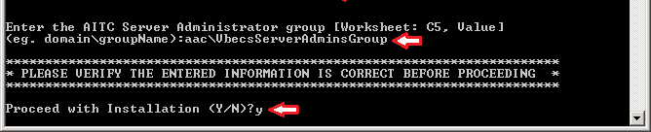
- The installation process will take 30 to 60 minutes to complete. During this time, the command prompt window will scroll executing commands and windows may appear and disappear. Take no action until the installation completes. *WARNING: If the Setup Result is not 3010, contact the VBECS development team for assistance (Figure 50).
Figure 50: SQL Server Installation Center
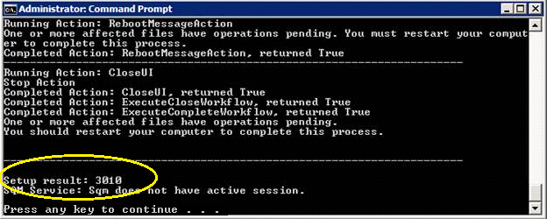
- Press any key to close the Command Prompt window.
- Using Windows Explorer, copy the C:\Program Files\Microsoft SQL Server\110\Setup Bootstrap\Log folder to C:\validation\sql (Figure 51).
Figure 51: Example of Saving the SQL Log Folder
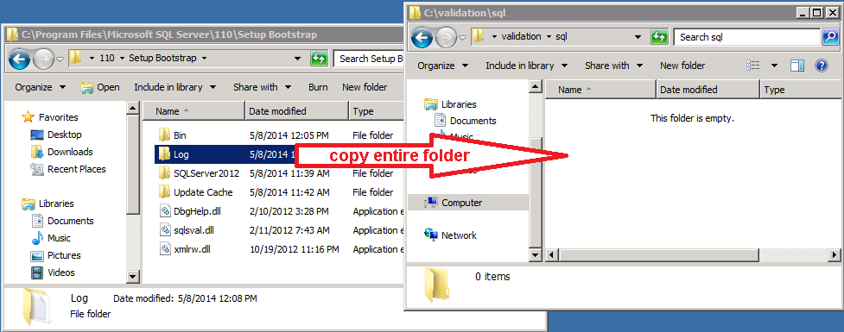
- Check the Copy SQL Server Setup Logs box on the Installation Checklist for this server.
- Using Windows Explorer, double-click on the C:\temp\SQL 2012\PatchVBECSSQL Windows batch file.
- Verify the output looks like Figure 52 and contains no errors. Press any key to continue.
Figure 52: PatchVBECSSQL Output
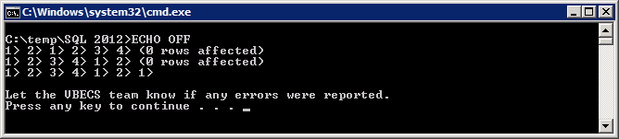
- Using Windows Explorer, double-click on the C:\temp\KB2645410\VS10SP1-KB2645410-x86 application.
- Click Next (Figure 53).
Figure 53: KB2645410 Welcome Screen
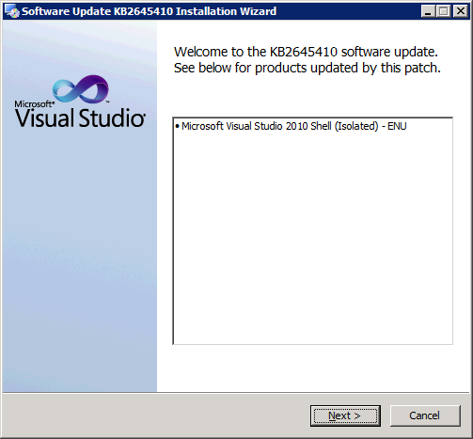
- Check the “I have read and accept the license terms” and click Next (Figure 54).
Figure 54: Accept the Terms
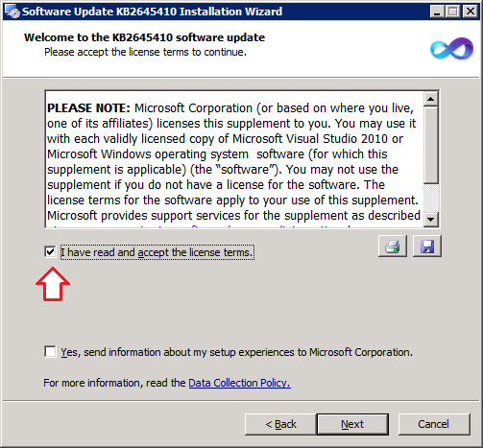
- The update will complete in less than 5 minutes; click Finish to close the final screen (Figure 55).
Figure 55: KB2645410 Installation Complete
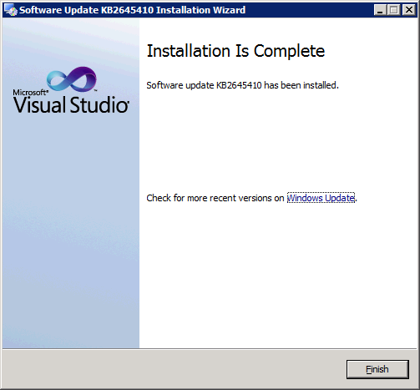
- Reboot the server.
- Check the SQL Server 2012 Installation box on the Installation Checklist for this server, and repeat this section for each remaining server in the current SQL Server system.
Wait for the current server to finish rebooting before installing on the next server. DO NOT reboot any server while SQL is installing. All 3 SQL servers must be online the entire time SQL is installing.

SQL AlwaysOn Server Configuration

- Login to Server A [Worksheet: 1, Name] with the domain level account that has administrator permissions to the SQL Servers.
- Open Start, All Programs, Microsoft SQL Server 2012, Configuration Tools, SQL Server Configuration Manager.
- Select SQL Server Services in the left pane. In the right pane, right-click SQL Server (MSSQLSERVER) and select Properties (Figure 56).
Figure 56: Example SQL Server Configuration Manager
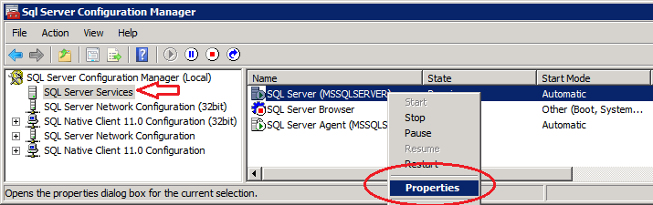
- Select the AlwaysOn High Availability tab. Verify the cluster name [Worksheet: 4, Name] appears in Windows failover cluster name, check Enable AlwaysOn Availability Groups and click OK (Figure 57).
Figure 57: Example of AlwaysOn High Availability Properties
Image Redacted
- Click OK to dismiss the warning message that displays (Figure 58).
Figure 58: Warning Message
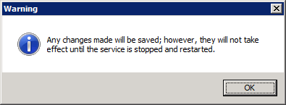
- Close SQL Server Configuration Manager.
- Reboot the server.
- Wait until the server finishes rebooting before continuing with the next step.
- Check the SQL AlwaysOn Server Configuration box on the Installation Checklist for this server, and repeat this section for each remaining server in the current SQL Server system.

Configure the Availability Group (AG)
- Login to Server A [Worksheet: 1, Name] with a domain level account that has administrator permissions to the SQL Servers.
- Using Windows Explorer, create a folder on the H: drive called AG (Figure 59).
Figure 59: Creating an H:\AG Folder
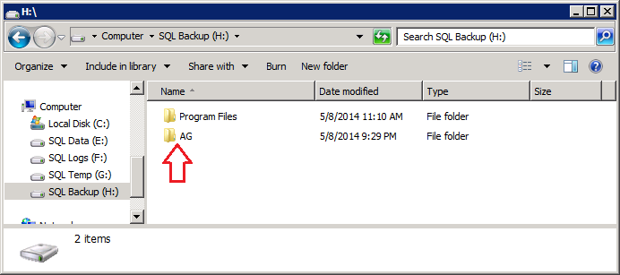
- Right-click on the AG folder and select Properties. Select the Sharing tab and click Share (Figure 60).
Figure 60: AG Properties – Sharing Tab
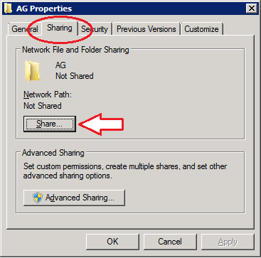
- Enter the SQL Service account [Worksheet: 7, Name] and click Add (Figure 61). Click the Permission Level column and check the Read/Write option for the SQL Service account. Click Share.
Figure 61: Example of Setting File Sharing for the SQL Service Account
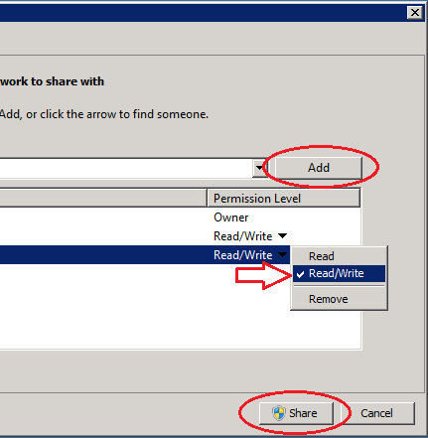
- Click Done to dismiss the File Sharing window after the share is created.
- Select the Security tab on the AG Folder Properties window and click Edit.
- Select the SQL Service account. If not checked, check the box for Full Control in the Allow column and click OK (Figure 62).
Figure 62: Example of Permissions for AG
Image Redacted
- Click OK to close the AG Properties window and close Windows Explorer.
- Check the Create AG folder box on the Installation Checklist for this server.
- Open Start, All Programs, Microsoft SQL Server 2012, SQL Server Management Studio.
- Verify the Server name field is Server A [Worksheet: 1, Name] and click Connect (Figure 63).
Figure 63: Example of Connecting to SQL Server
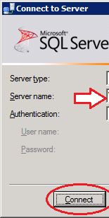
- In the Object Explorer, right-click on Databases and select New Database (Figure 64).
Figure 64: Example of Creating a New Database
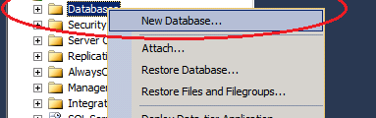
- Enter GarbageA in the Database name field and click OK (Figure 65). Note: this database is needed to fulfill a SQL Availability Group creation requirement.
Figure 65: Example of New Database
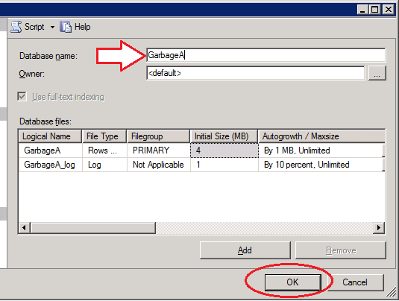
- Check the Create Database for Item 5a box on the Installation Checklist.
- Repeat Steps 12 and 14 to create a new database named GarbageB. If you have Items 5c, 5d, 5e or 5f on your Data Center Worksheet, repeat Steps 12 and 13 to create a new database named GarbageC, GarbageD, GarbageE and GarbageF database respectively.
- In the Object Explorer: expand Databases, right-click on the GarbageA database and select Tasks, Back Up….
Figure 66 : Example of Object Explorer
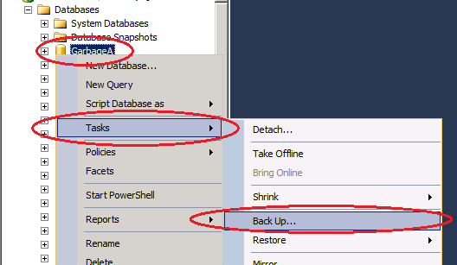
- The Back Up Database window appears. Click OK (Figure 67).
Figure 67: Example of Back Up Database
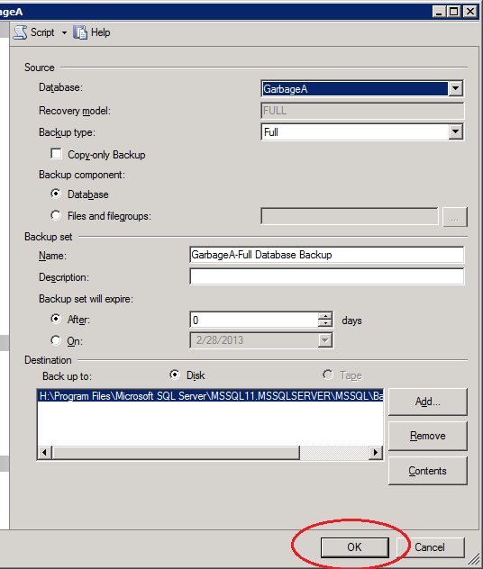
- Click OK to dismiss the successful backup message (Figure 68).
Figure 68: Backup Completed Successfully
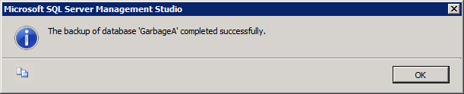
- Check the Backup Database for Item 5a box on the Installation Checklist.
- Repeat Steps 16 through 19 to back up the GarbageB database. If you have Items 5c, 5d, 5e or 5f on your Data Center Worksheet, repeat Steps 15 through 18 to back up the GarbageC, GarbageD, GarbageE and GarbageF database respectively.
- In the Object Explorer, expand the AlwaysOn High Availability folder.
- Right-click on Availability Groups and select New Availability Group Wizard (Figure 69).
Figure 69: Example of Starting New Availability Group Wizard
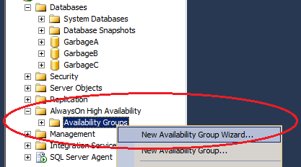
- Click Next (Figure 70).
Figure 70: New Availability Group
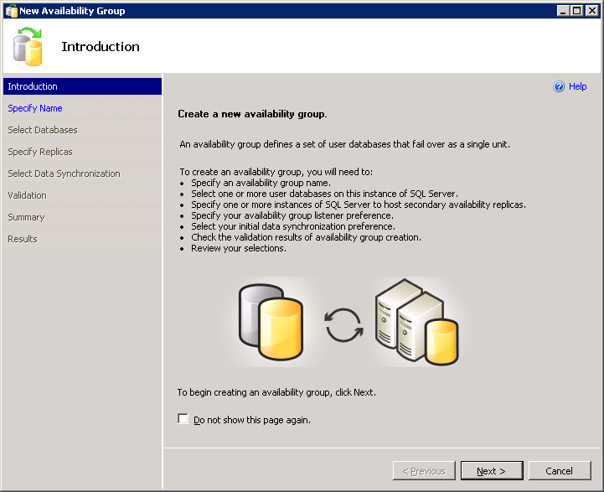
- Enter the value from [Worksheet: 6a, Name] and click Next (Figure 71).
Figure 71: Example of Specifying the Availability Group Name
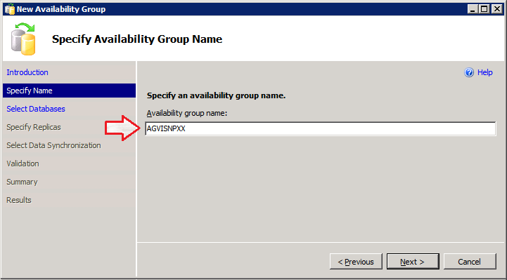
- Select the one database that corresponds to the Availability Group entered in the previous step (i.e., check GarbageA when creating the Availability Group for Item 6a, check GarbageB when creating the Availability Group for Item 6b, etc.). Click Next (Figure 72).
Figure 72: Example of Selecting the Availability Group Database
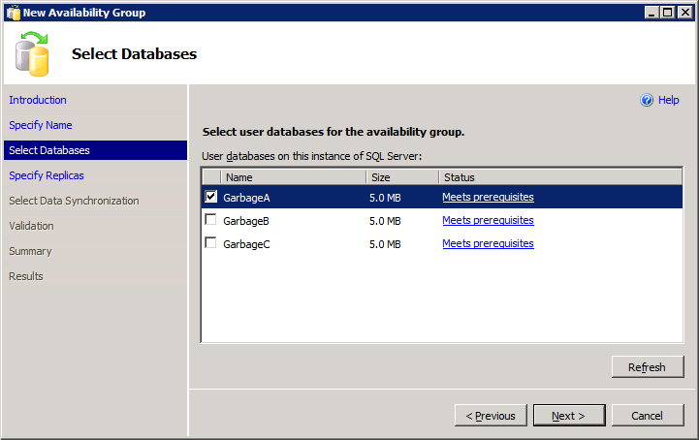
- Check the following for the Primary Initial Role and then click Add Replica… (Figure 73):
  - Automatic Failover (Up to 2)
  - Synchronous Commit (Up to 3)
Figure 73: Example of New Availability Group – Specify Replicas
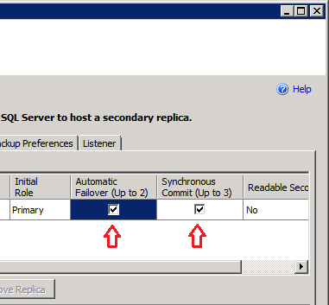
- When prompted to Connect to Server, enter Server B [Worksheet: 2, Name] in the Server name field and click Connect (Figure 74).
Figure 74: Connect to Server B
Image Redacted
- Check the following for the Secondary Initial Role and then click Add Replica… (Figure 75).
  - Automatic Failover (Up to 2)
  - Synchronous Commit (Up to 3)
Figure 75: Example of New Availability Group
Image Redacted
- Click Add Replica…
- When prompted to Connect to Server, enter Server C [Worksheet: 3, Name] in the Server name field and click Connect (Figure 76).
Figure 76: Connect to Server C
Image Redacted
- Click the Backup Preferences tab and select Primary (Figure 77).
Figure 77: Example of Backup Preferences
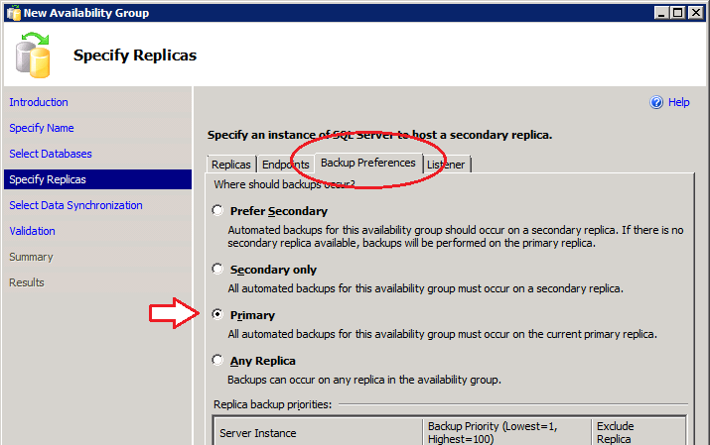
- Click the Listener tab (Figure 78) and:
  - Select Create an availability group listener.
  - Set Listener DNS Name to the value from [Worksheet: 5a, Name].
  - Set Port to the value from [Worksheet: 5a, Port].
  - Set Network Mode to Static IP.
  - Click Add.
Figure 78: Example New Availability Group – Listener
Image Redacted
- In the IPv4 Address field, enter the value from [Worksheet: 5a, Public IP] and click OK (Figure 79). The Add IP Address window should display a second time; if it does not, click Add from Figure 78. In the second Add IP Address window, enter the value from [Worksheet: 5a, DR IP] in the IPv4 Address field and [Worksheet: C9, Value] in the Subnet Mask field and click OK.
Figure 79: Example of Add IP Address
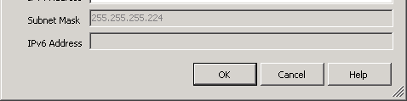
- The Listener has been configured. Click Next (Figure 80).
Figure 80: Example of New Availability Group – Specify Replicas
Image Redacted
- Enter the AG folder share created on Server A. Click Next (Figure 81).
Figure 81: Example of Select Initial Data Synchronization Setting
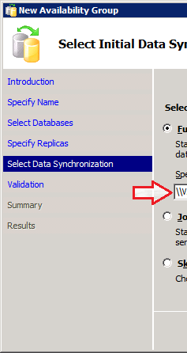
- Click Next (Figure 82).
Figure 82: Example of New Availability Group Validation
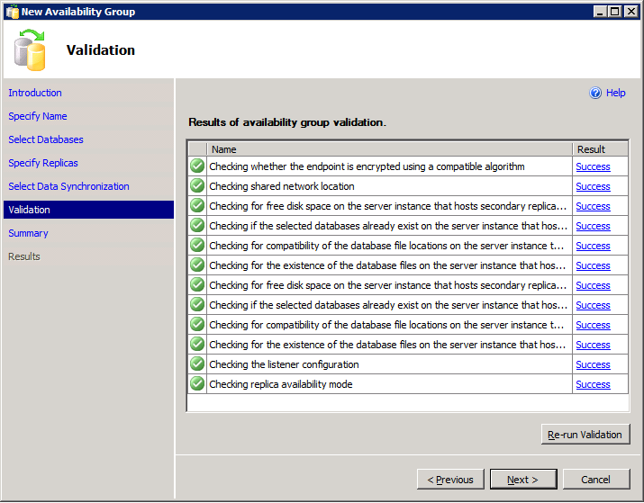
- Click Finish (Figure 83).
Figure 83: Example of New Availability Group Summary
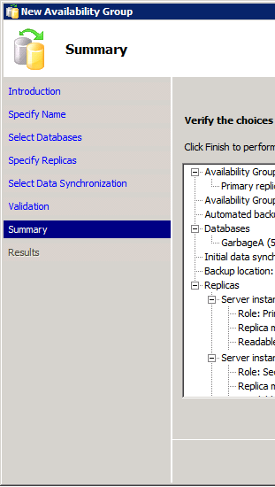
- Verify the wizard completes successfully (Figure 84). Place a screen capture in the validation.rtf document.
Figure 84: New Availability Group – Results
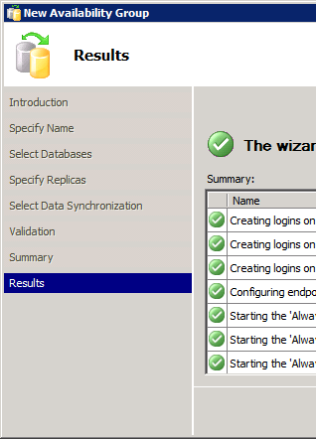
- Check the Configure the Availability Group (AG) for Item 5a box on the Installation Checklist.
- Repeat Steps 21 through 39 using the Data Center Worksheet values for Item 6b.
- If you have Items 5c, 5d, 5e or 5f, repeat Steps 21 through 38 using the Data Center Worksheet values for Items 6c, 6d, 6e and 6f.

Post-Installation Tasks
- Verify that Backup network adapters are enabled and configured with IP addresses for all servers and check the Re-Enable Network Adapters for Backups box on the Installation Checklist for this server.
- Using Windows Update, install Microsoft Visual Studio Service Pack 1(KB2635973) on Servers A, B and C and check the MS Visual Studio Service Pack 1(KB2635973) Installed box on the Installation Checklist for these servers.
- Print and complete the Date Completed and EO Database Administrator Name fields on the validation.rtf document for each server.
- Sign and date the installation checklist.
- Verify that the cluster name of the current SQL Server system [Worksheet: 4, Name)] is recorded at the top in the Cluster Name field.
- Scan Pages 2 through 4 (containing the checklist) into an electronic copy; name this document Installation Validation <cluster name> mmddyyyy.
- Save the scanned copy to the C:\validation folder on each server [Worksheet: (1, 2 and 3; Name)].
- Email a copy to the VBECS Team (Mail_Group_Redacted).
- The VBECS Team designee executes the VBECS 2.0.0 SQL Server 2012 Post-Installation Checklist. Upon completion, the checklist will be signed and dated and a scanned copy will be filed in the VSS Doc, VBECS Device History Record (DHR), VBECS 2.0.0 Installation Records, Completed SQL Post-Installation folder.
This page intentionally left blank.

Index

C
Cluster Installation 23
Configuration Worksheets 10
Configure the Availability Group (AG) 44
Create the Cluster 26
I
Initial Configuration Tasks 13
Initialize the New Disks 22
Install Clustering 23
Installation Checklist 10
Introduction 9
P
Prerequisites 10
R
Revision History 3
S
Screen Captures 10
Server Configuration 13
SQL AlwaysOn Server Configuration 43

This is the last page of VistA Blood Establishment Computer Software (VBECS) 2.0.0 SQL Server 2012 Installation Guide.

